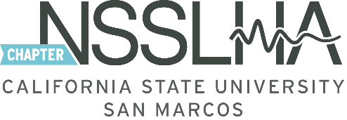

National Student Speech Language Hearing Association – CSUSM Chapter

Thanks for your interest in NSSLHA!
Please complete this form either email it to csusmnsslha@gmail.com or return it in person to an officer. Please submit your membership dues along with your registration form (Cash or Checks ONLY - Checks payable to ASI - NSSLHA). If registering via email – we will reply with further instructions regarding how to make your payment. Your membership is not active until your payment is received.

First & Last Name: ________________________________________ Student ID: ___________________

Major(s)/Minor(s): _________________________________________________________________________

Current Student Class/Status:

Undergraduate Students (Circle one): Freshman Sophomore Junior Senior

Graduate Students: M.S. Cohort # _____

Post-Bac Students: Year _______ Cohort # _______

Current Mailing Address: __________________________________________________________________

__________________________________________________________________

CSUSM E-mail: ________________________________________ Phone: _________________________

Activities you would like to see NSSLHA plan: _______________________________________________

___________________________________________________________________________________________

Are you interested in a leadership role within NSSLHA: Yes No Maybe

If yes, which one? Committee? Officer position? _____________________________________

Are you a National NSSLHA Member: Yes No

Membership Options (select one):

1 Year Membership $20.00 2 Year Membership $35.00

FOR OFFICER USE ONLY

Payment Type Received (circle one): Cash Check Amount Paid: $_____________

Date Payment Received: ____________________ Membership Expires: ________________________

